ASSIGNMENT 5

- What will be the output of 3 + 4 ** 6 - 9 * 10 / 2?
Ans: 4054.0

- Count the number of vowels present in a string.
Code:
string=input("Please enter a String: ")

count=0
for i in range(0,len(string)):
if(string[i]=='a' or string[i]=='e' or string[i]=='i' or string[i]=='o' or string[i]=='u'):
count=count+1

print("\nThe number of vowels in given string are: ",count)

Output:
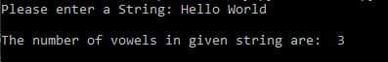

- Find out the area of triangle, take base and length from user.

Code:

base=float(input("Please enter the Base: "))
height=float(input("\nPlease enter the height: "))

area=0.5*base*height
print("\nThe area of triangle with Base: "+str(base)+" and Height: "+str(height)+" is: "+str(area))

Output:

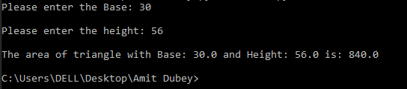

- Print the Calendar on the terminal. Ask year as input from user.

Code:

def make_calendar(yyyy, sDay):
posStart = week_days.index(sDay)

if is_leap(yyyy):
calender[1] = ('Feburary', range(1, 29 + 1))

for mm, days in calender:
print('{0} {1}'.format(mm, yyyy).center(20, ' '))
print(''.join(['{0:<3}'.format(w) for w in week_days]))
print('{0:<3}'.format('')*posStart, end='')

for day in days:
print('{0:<3}'.format(day), end='')
posStart += 1
if posStart == 7:
print()
posStart = 0
print('\n')

def is_leap(yyyy):
if yyyy % 4 == 0:
if yyyy % 100 == 0:
if yyyy % 400 == 0:
return True
else:
return False
else:
return True
else:
return False

calender = [('January', range(1, 31 + 1)),
('Feburary', range(1, 28 + 1)),
('March', range(1, 31 + 1)),
('April', range(1, 30 + 1)),
('May', range(1, 31 + 1)),
('June', range(1, 30 + 1)),
('July', range(1, 31 + 1)),
('August', range(1, 31 + 1)),
('September', range(1, 30 + 1)),
('October', range(1, 31 + 1)),
('November', range(1, 30 + 1)),
('December', range(1, 31 + 1))]

week_days = ['Mo', 'Tu', 'We', 'Th', 'Fr', 'Sa', 'Su']

yr=int(input("Please enter the year: "))
startday=input('Please enter the startting day of the year i.e Mo,Tu,We,Th,Fr,Sa,Su: ')
make_calendar(yr,startday)

Output:
